SCREEN SHOTS

Login Page

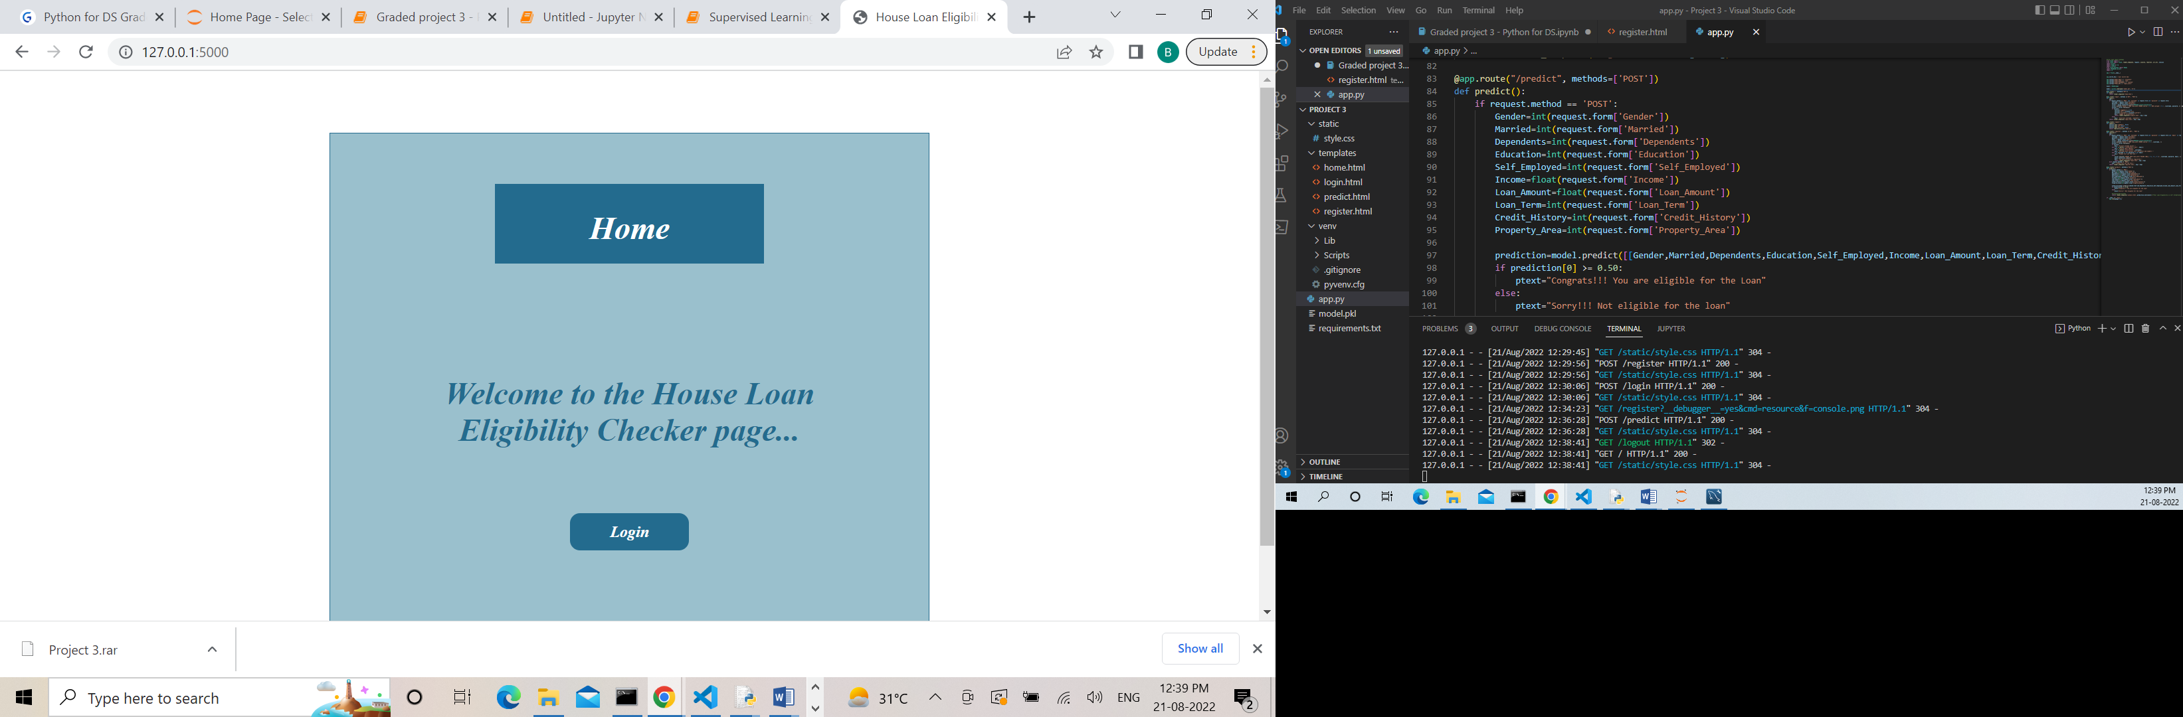

LOGIN PAGE



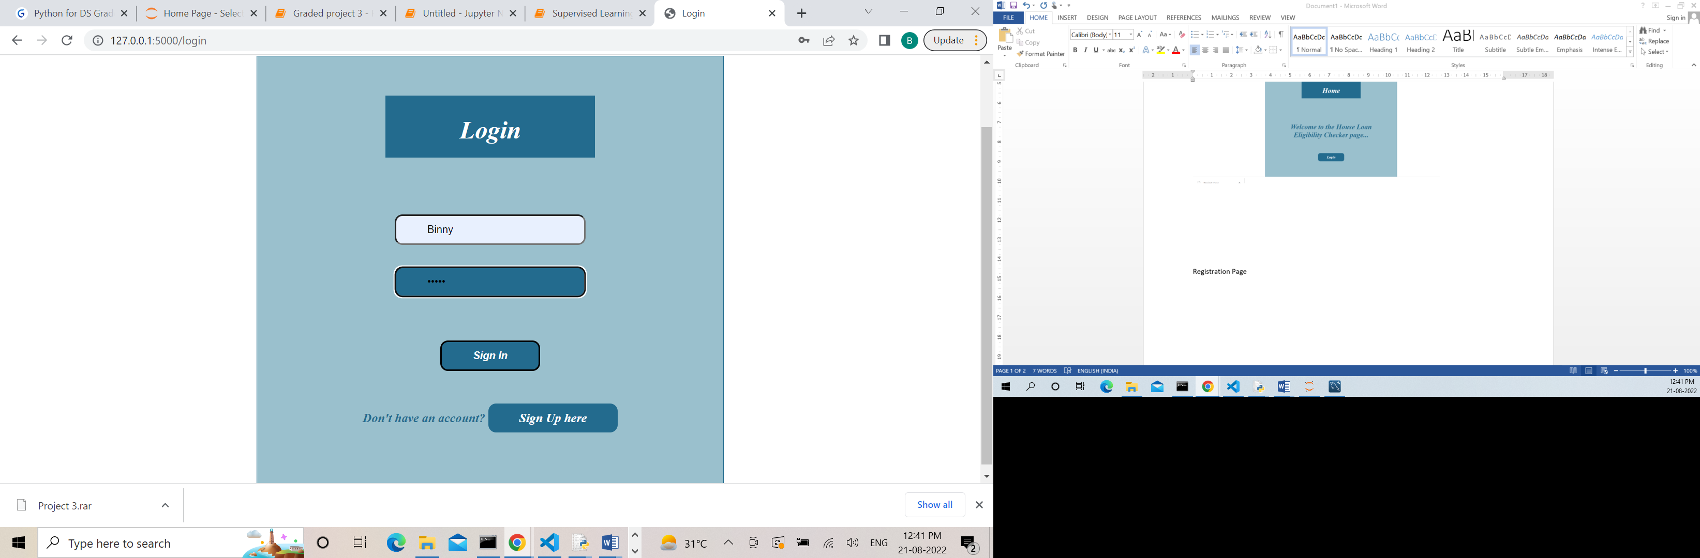

lubna

Registration Page

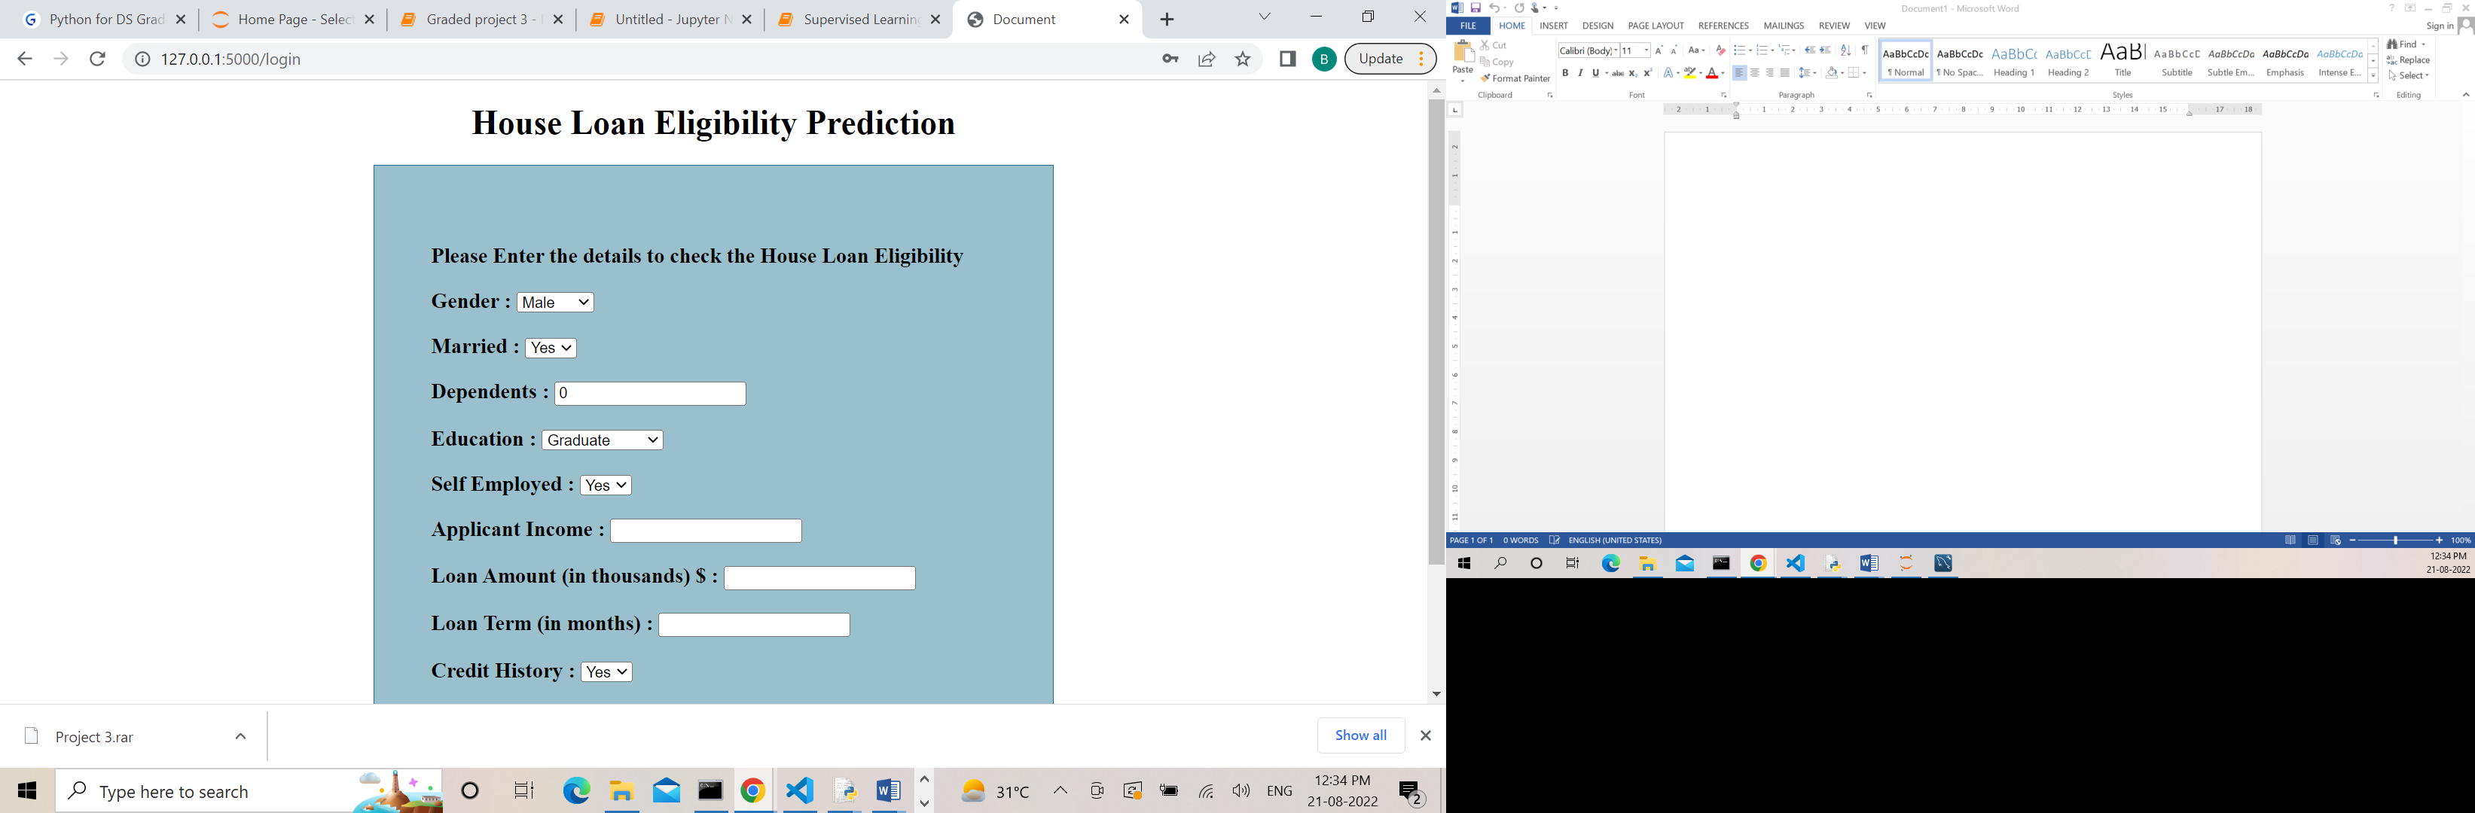

Predictability

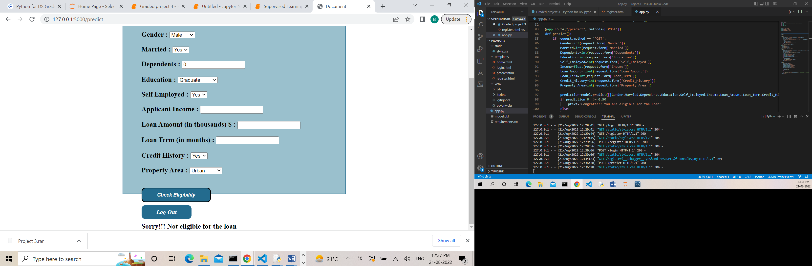

DATA IN THE DATABASE

